# High Level Design

This document explains the High Level Design approach to create a Pool1 prototype to the FDA Challenge. This document is a “quick and easy” Agile style reference document that was used for creating the solution while implementing the prototype.

## Assumptions

* 1. Development Environment: We based our design on the mirrored site of the FDA site from the repository at <https://github.com/FDA/open.fda.gov>. Using the mirrored site helps in building a quicker prototype as functions in the code base can be reused or enhanced rather than starting from scratch.
  2. UI and Style guidelines: As the mirrored site itself will be used as the base for developing the prototype, the same UI and style will be used in the prototype also.
  3. Data sets and APIs: The APIs are not complete and may not provide full functionality. We assume that the results returned by the APIs are correct for the prototype even if it is incomplete. For example, there is no API to list the drugs, but similar results can be achieved by counting the drug’s name.

## Design Approach

A new tab was added to the mirrored web site to display the prototype. The same graphing components and filter components will be used for the User Interface. Given below is an illustration of the new tab (this is not the actual tab that will be created):

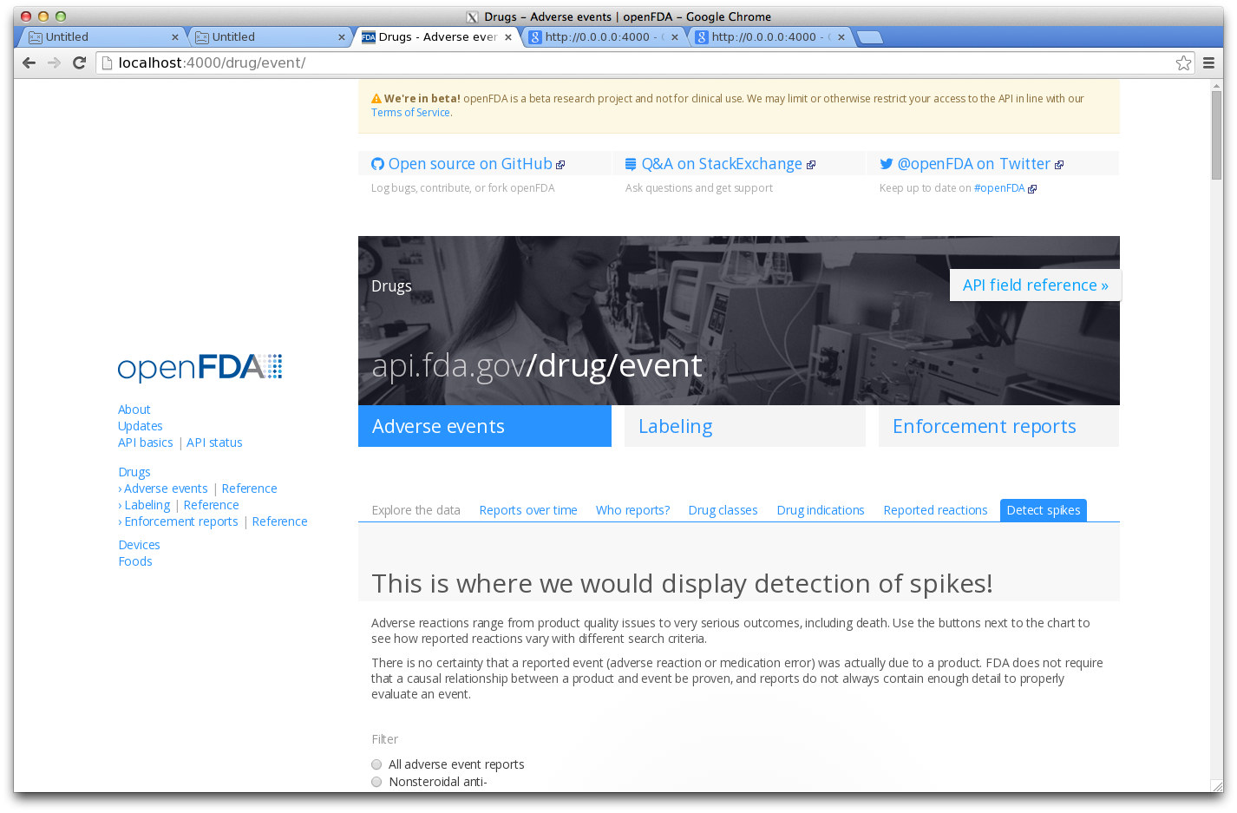

## Spike detection tab components

The new tab will contain the following components:

1. A chart that will display the data for the drug selected when the “Display Chart” button is clicked
2. A drop down of the drugs for which adverse event data is available. Users will select a drug from this list.
3. A slider on the chart to display data and information at different points
4. Filters using Radio buttons to show progressive challenge levels
5. Information boxes below to display additional information

## APIs needed

* 1. API for getting a list of drugs in the data set

https://api.fda.gov/drug/event.json? search=&count=patient.drug.medicinalproduct&limit=1000

This API actually gives a count for all the medicinal products/drugs to use in the drug list drop down. As there is no direct way of getting a list of drugs, this API can be used in an indirect way as the result set contains both the drug name and the count.

* 1. API for getting data of a specific drug

[https://api.fda.gov/drug/event.json?search=receivedate:[YYYYMMDD+TO+YYYYMMDD]+AND+patient.drug.medicinalproduct:DRUGNAME&count=receivedate](https://api.fda.gov/drug/event.json?search=receivedate:%5bYYYYMMDD+TO+YYYYMMDD%5d+AND+patient.drug.medicinalproduct:DRUGNAME&count=receivedate)

The above API creates a date wise count of events for a drug between a date range. The format for date is YYYYMMDD. The proper drug name has to be used in the DRUGNAME parameter.

## Block Diagram

Open FDA Data/APIs

Web Server

App Server

Mirrored FDA site

(Local Server)

Other filters/options

New Spikes Tab

Drug List

Chart

## Software and components used

All software and components used are Open Source.

|  |  |  |  |
| --- | --- | --- | --- |
| # | Item | Software | Notes |
| 1 | Server | Linux | Hosted locally for development and for the prototype |
| 2 | Web Server | Node.js |  |
| 3 | Application Server | Node.js |  |
| 4 | Development Language/Toolkit | Ruby, python, JavaScript |  |
| 5 | Chart component | C3.js |  |
| 6 | APIs | Provided by FDA |  |